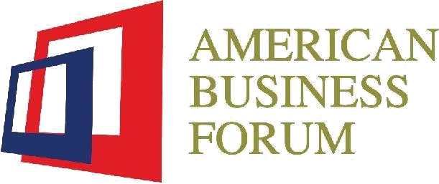

**American Business Forum- Annual Updation Form 2025**

**PRESENT ADDRESS:**

Tricon Corporate Office 9th Floor Regus Center Gulberg Lahore.

|  |  |
| --- | --- |
|  |  |

# VISION

To be the leading forum for business and social advocacy, representing American businesses in Pakistan with focus on fostering economic partnerships, promoting bilateral engagements between people and governments for socio-economic prosperity.

**OBJECTIVES**

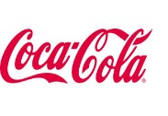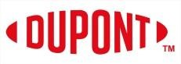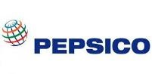American business forum is a non-profit body formed by Pakistani businesses in USA. Its purpose is to provide a platform to American companies for business expansion, resolution of issues and attracting FDI in Pakistan. In this regard, interaction with provincial as well as federal governments is one of its key objectives. ABF endeavors to play a key role in promoting trade and investment which are vital for the economic revival of Pakistan. This member-focused association aims to help the general public by development of human resource in Pakistan and convincing people in fulfilling their social responsibilities. Its philosophy is that companies should be an integral part of the community in which they are operating, since corporate sector has the required expertise and the resources to undertake corporate social responsibilities.

**ABF MEMBERS**



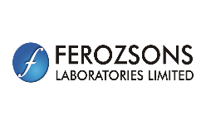



















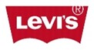 

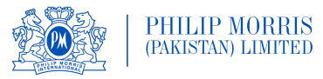 



   

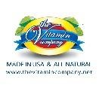 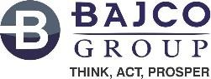   

Figure 1



1. **Name of Business / Brand:**



1. **Nature Of Business:**
2. **Registered Office (Please mark):**



U.S Registered

Franchise

Pakistan Registered

Vendor

Partner

Distributor

**4**.

**Ownership / Affiliation:**

**5. Contact Details (Pakistan Office):**

Cell Number: **________________________**

Website: ____________________________

Email: __________________________________

**6. Contact Details US Office**

Cell Number: ____________________________

Email: __________________________________

Website: ________________________________

**7**. **Number of Business Branches / Offices:** 

**8. Business Branches / Offices with Address (if any):**

1. -------------------------------------------------------------------------

2. -------------------------------------------------------------------------

3. -------------------------------------------------------------------------

4. -------------------------------------------------------------------------

**9. Identify your CSR Activities:**

Activity 1: ______________________________________________________

Activity 2: ____________________________________________________________

Activity 3**:** ____________________________________________________________

**10. Can you provide the details of the equity structure?**

1) Percentage of US Equity ______________________________

2) Amount of US Equity in US Dollars __________________________

3) US Citizenships status of Member Representatives ________________________

**11. National Tax Number (NTN): ________________________**

**12. GST Registration Number**: ______________________________

**13. What type of business or organization are you most closely affiliated with? Please mark.**

1) Information Technology

2) Banking & Financial Services

3) Agriculture & Chemicals

4) FMCG’s & Manufacturing

5) Food & Beverages

6) Marketing & Consultancy

7) Pharmaceutical

8) Logistics & Shipping

9) Tobacco

10) Other

**14. What sustainability efforts has your organization implemented recently?**

**15. Does your organization intend to increase its presence or operations in Pakistan during the next fiscal year?**

1) Yes

2) No

**16. How would you rate Pakistan’s Perception Internationally?**

1) Same

2) Better

3) Worse

**17. How many employees currently work for your organizations?**

__________________________

**18. What is the current strength of your workforce?**

1) Outsourced ____________

2) Direct ________________

3) Contract ______________

4) Others _______________

**19. What is your organizations annual turnover in PKR Million?**

1) _____________________

**20. What is your organization’s gross revenue from Exports in PKR Million?**

1) _____________________

**21. What is the total amount your Organization has spent on CSR/Diversity initiatives in 2024 in PKR Million?**

1) ________________________

**22. How would you rate Ease of Doing Business in the country?**

1) Same

2) Better

3) Worse

**23) How would you rate the present overall business climate in the country?**

1) Same

2) Better

3) Worse

**24) Do you feel optimistic about the future of operating your business in the prevailing economic environment?**

1) Short- term

2) Middle-term

3) Long-term

# UNDETRAKING

I / we do hereby apply for membership of the **American Business Forum (ABF)** and undertake to abide by the Memorandum and Article of Association of ABF on being enrolled as member. Particulars of my/our business are

below:

**DECLARATION**

1. Our particulars are true to the best of my knowledge & belief.
2. Hold myself/ourselves responsible for all legal judicial consequences arising due to false statement.

Yours faithfully,

Applicant Name: __________________________

Designation: _____________________________

Signature: _______________________________

Stamp of Firm/Co._________________________

Date: ___________________________________